**第234页**

#include<iostream>

usingnamespacestd;

classstudent

{public:

voidinput(student&stu);

voidoutput(student&stu);

private:

charname[20];

unsignedintid;

doublescore;

};

voidstudent::input(student&stu)

{cout<<"name?";

cin>>stu.name;

cout<<"id?";

cin>>stu.id;

cout<<"score?";

cin>>stu.score;

}

voidstudent::output(student&stu)

{cout<<"name:"<<stu.name<<"\tid:"<<stu.id<<"\tscore:"<<stu.score<<endl;}

intmain()

{students;

s.input(s);

s.output(s);

}

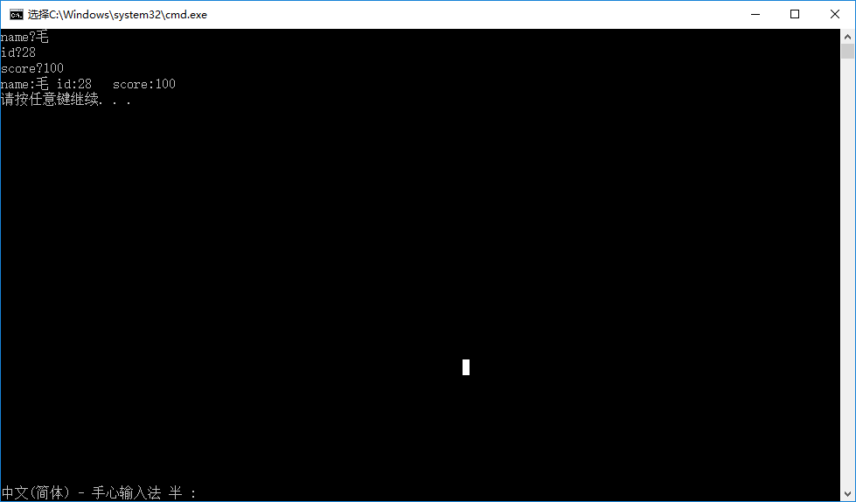

**第242页**

**第1题**

#include<iostream>

usingnamespacestd;

classBook

{public:

voiddisplay();

voidborrow();

voidrestore();

charbookname[100];

doubleprice;

intnumber;

};

voidBook::display()

{cout<<"bookname:"<<bookname<<"\nprice:"<<price<<"\nnumber:"<<number<<endl;}

voidBook::borrow()

{number-=1;

cout<<"number:"<<number<<endl;

}

voidBook::restore()

{number+=1;

cout<<"number:"<<number<<endl;

}

intmain()

{inti;

Bookb;

cout<<"please input the bookname:";

cin>>b.bookname;

cout<<"please input the price:";

cin>>b.price;

cout<<"please input the number:";

cin>>b.number;

for(intx=0;x<10;x++)

{cout<<"\nwhat do you want to do?"<<"\ndisplay--1 borrow--2 restore--3"<<endl;

cin>>i;

switch(int(i))

{case1:b.display();break;

case2:b.borrow();break;

case3:b.restore();break;

}

}

}

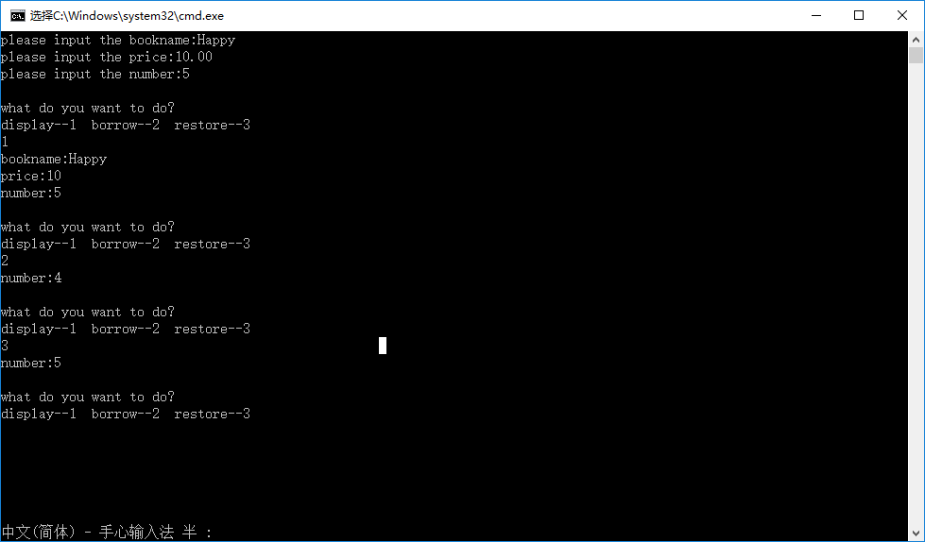

**第3题**

#include<iostream>

usingnamespacestd;

classstudent

{doublescore;

staticdoubletotal;

staticintcount;

public:

voidscoretotalcount(doubles);

staticdoublesum();

staticdoubleaverage();

};

doublestudent::total=0;

intstudent::count=0;

voidstudent::scoretotalcount(doubles)

{score=s;

total+=s;

count+=1;

}

doublestudent::sum()

{returntotal;}

doublestudent::average()

{returntotal/count;}

intmain()

{intnum;

doubles;

studentA;

cout<<"How many students in the class?"<<endl;

cin>>num;

for(inti=1;i<=num;i++)

{cout<<"Please input the score of NO."<<i<<" student : ";

cin>>s;

A.scoretotalcount(s);

}

cout<<"The total score of this class is : "<<student::sum()<<endl;

cout<<"The average score of this class is : "<<student::average()<<endl;

}

